Vanderbilt
Med-Peds
Residency Program

Goals and Objectives
2024-2025

Ashley Karpinos, MD, MPH
Program Director

Vanderbilt Internal Medicine - Pediatrics Residency Program
Goals and Objectives

Table of Contents

TOPIC PAGE

1. | Overall goals and objectives of the program…….……………………………………………………………………………. | 3
2. | General program description and program aims (updated from ACGME self-study 2017)…………………………  program………………………………………………………………………………… | 4
3. | Lines of guided supervisory responsibility………………………………………………………………………………….…… | 5
4. | Med-Peds example 4-year rotation schedule…………………………………………………………………………………. | 8
5. | ACGME Internal Medicine Sub-competencies (milestones) | 9
6. | ACGME Pediatric Sub-competencies (milestones) | 10
7. | Curriculum Specific to Med-Peds……………………………………………………………………………………………………. | 11-22
 | a. PGY 1: Med-Peds…………………………………………………………………………………….…………………………… | 11
 | 1) Med-Peds Conference Series……………………………………………………………………………………………………………. | 11
 | 2) Med-Peds Combined Continuity Clinic………………………………………………………………………………………………. | 12
 | 3) Med-Peds Scholarly Project………………………………………………………………………………………………………………. | 14
 | b. PGY 2-3: Med-Peds………………………………………………………………………………………………………………. | 15
 | 1) Med-Peds Conference Series……………………………………………………………………………………………………………. | 15
 | 2) Med-Peds Combined Continuity Clinic………………………………………………………………………………………………. | 17
 | 3) Med-Peds Scholarly Project………………………………………………………………………………………………………………. | 18
 | c. PGY 4: Med-Peds…………………………………………………………………………………….…………………………… | 19
 | 1) Med-Peds Conference Series……………………………………………………………………………………………………………. | 19
 | 2) Med-Peds Combined Continuity Clinic……………………………………………………………………………………………… | 22
 | 3) Med-Peds Scholarly Project………………………………………………………………………………………………………………. | 22

Vanderbilt Internal Medicine and Pediatrics Residency Program
Overall program goal and objectives

Goal of the Med-Peds Residency Program:
The goal of the Vanderbilt Internal Medicine and Pediatrics (Med-Peds) Residency Program is to train physicians in developing the competencies to function as exceptional independent general Internists and Pediatricians caring for adults and children with a wide range of medical needs including preventive healthcare, chronic disease management and acute inpatient and outpatient care. From this generalist training, Med-Peds physicians may enter careers as generalists or pursue further sub-specialty training. Our goal is to train Med-Peds physician leaders who pursue a diverse range of careers.

Objectives of the Med-Peds Residency Program

The Med-Peds residency training program at Vanderbilt University Medical Center has been designed to enable residents, upon completion of the program, to:

1. Apply established and evolving knowledge in the biomedical, clinical, and epidemiological sciences related to medicine and pediatrics as well as related knowledge in the social-behavioral sciences to their care of child, adolescent, and adult patients. (ACGME Competency Medical Knowledge)

2. Provide compassionate, appropriate, and effective patient care by

a. using data about a patient (history, physical examination, laboratory and imaging studies) along with medical knowledge to create a differential diagnosis, plan for further evaluation, and comprehensively manage patients with a variety of disorders; (ACGME Competency Patient Care)

b. developing a relationship with patients and their families in which health care needs are identified and addressed collaboratively in the context of the patient as a whole person. (ACGME Competency Interpersonal and Communication Skills)

3. Improve the patient care that they provide by continuously assessing their performance, incorporating feedback and pursuing learning related to improvement opportunities. (ACGME Competency Practice-based Learning and Improvement)

4. Function effectively with the system of health care beyond the clinical encounter to call effectively on additional resources to provide optimal health care for patients with a variety of disorders. (ACGME Competency Systems-based Practice)

5. Conduct their professional life in accordance with the expectations of the profession of medicine and society, manifested through a commitment to carrying out professional responsibilities, adherence to ethical principles, and sensitivity to patients of diverse backgrounds. (ACGME Competency Professionalism)

6. Pursue a career in Medicine and/or Pediatrics caring for children and adults as a generalist or as a sub-specialist, and seeking to make an impact as a leader in the medical field improving the delivery of health care in a variety of venues including general medicine, subspecialty medicine, population medicine, health policy, biomedical research, or international health medicine.
Vanderbilt Internal Medicine - Pediatrics Residency Program

Program Description

The Vanderbilt Internal Medicine – Pediatrics (Med-Peds) Program prepares residents to be exceptional generalists for independent practice in the care of both children and adults. From this generalist training residents enter careers as inpatient and/or outpatient generalists; or seek further subspecialty training for adults, children or both. We do not have an expected career phenotype for the graduates of our program, but rather believe that diversity in our residents’ career choices enriches our program’s learning environment. The character phenotype for our program is clinical excellence, academic excellence, effective leadership development and kindness. Our curriculum is designed to promote these traits.
Over the past 10 years, 88% of our graduates have developed careers in academic medicine. Others hold leadership roles as clinicians in their communities, at the Center for Disease Control (CDC), in state health departments, and at global health sites. Our Med-Peds faculty mirror the diversity in the resident career choices. Our Med-Peds primary care faculty includes clinician-educators and physician scientists with expertise in primary care, acute outpatient and inpatient care, palliative care, sports medicine, pharmacology, obesity prevention, addiction medicine, care of persons with disabilities, medical education, quality and patient safety, public health, and health services research.
Our residents are structurally and culturally well integrated into both parent programs. The Vanderbilt Internal Medicine and Vanderbilt Pediatric Programs have rich clinical experiences with robust clinical volume, and significant exposure to all types of patients with common problems, complex clinical scenarios, and rare diagnoses.
Our Med-Peds program identity is fostered through two uniquely Med-Peds curricular components: the combined Med-Peds Resident Clinic and the Med-Peds weekly education conference.

Program Aims

- To provide exceptional clinical training in internal medicine and pediatrics that is patient-centered and addresses health across the continuum of the lifespan, which prepares residents for independent practice in the care of children and adults
- To promote and expect academic and clinical excellence
- To provide opportunities for scholarly inquiry and scholarship by providing resources, mentorship and an environment of intellectual curiosity
- To promote excellence in teaching (for patients/students/colleagues)
- To promote leadership development
- To create a culture of support, caring and wellness for residents and faculty
- To foster a culture that supports diversity, equity, inclusion, and belonging for residents and faculty
- To promote professionalism and integrity for interactions with patients, staff, colleagues, and the community
- To promote awareness and engagement of the community and the role of the community in health
Med-Peds Residency Guided Supervisory Lines of Responsibility
Reviewed and Updated July 2024

Overall goals for rotations

Residents will have the opportunity to assess and follow patients longitudinally in the outpatient continuity clinic setting including health maintenance visits, acute care visits, and chronic diseases management visits. They will also assess and manage patients acutely on the inpatient ward services including adult and pediatric, general, subspecialty and ICU ward rotations. Rapport with the patient and family when appropriate will be established with the resident having graded responsibility for planning the course of care and communicating with the patient, and family. The attributes of patient care competency will be prominently displayed in this setting, where the resident will apply medical knowledge thus far obtained, learn about patient problems through practiced-based learning and optimize care venues through systems-based learning and problem solving. The success of patient care will entail effective interpersonal and communication skills between the resident and patient as well as with the outpatient physicians. How one attends to these diverse demands is one example of professionalism. The objectives for each rotation are listed in later sections of this document.

Guided supervision in patient care and clinical education

Because the goal of the Med-Peds residency program is to create physicians capable of serving as an independent Internist and Pediatrician, each resident upon completion of the program must have demonstrated the ability to care for adults and children with general medicine and general pediatric issues without the need for oversight and modification of their work by faculty. During the residency program, faculty will encourage assumption of independence as expeditiously as the resident's increasing knowledge, experience, and professional maturity permit, in keeping with both safe patient care and sound educational principles.

The responsibility of the attending physician for the patient is never relinquished; the amount of freedom to make and implement decisions and the amount and timing of faculty supervision will change depending on an individual resident's demonstrated performance, as judged by on-going faculty review of performance as the resident progresses through the program.

Attending physicians serve as a resource for residents and are available (by phone, paging or in person) to residents for guidance or assumption of care as needed. Teaching rounds occur daily on both adult and pediatric services.

A typical care team consists of a supervising attending, one or two upper-level resident (PGY2-4), one to four interns, and often medical students and fellows (on some subspecialty services). In this team, there is a hierarchy of increasing authority and responsibility as experience is gained. For example, the upper-level resident has more authority and responsibility than the interns, and interns more than the medical students. Judgments on delegation of responsibility are made by the attending; based on his or her direct observation and knowledge of each team member’s skills and ability. The degree of supervision may vary with the clinical circumstances and the developmental stage of the Med-Peds resident. Attending rounds provide a format for in-depth discussion of clinical presentation, pathophysiology, and management. All major clinical decisions are discussed and all plans are reviewed with an attending.

Residents are expected to develop independent practice in three stages:

Stage 1 (PGY-1 Interns)
1. The intern functions as an integral member of care team.
2. The intern sees patient initially.
a. Performs complete history and physical examinations on all new in-patients and/or outpatients for whom he or she has primary responsibility.
b. Examines all data related to the management of patients he or she has evaluated.
c. Synthesizes all available information to generate differential diagnoses and subsequent diagnostic and therapeutic plans.
d. Communicates the synthesis of the above information in both an oral and written format to his or her supervising faculty member.
e. Follows-up on all tests and procedures ordered for patients under his or her care.
3. In continuity clinic, all patients are presented in detail to the clinical faculty member. In the first 6 months of the intern year, the faculty member interviews and examines the patient with the intern, followed by an extensive discussion of differential diagnosis proposed approaches, etc. In the latter part of the internship year, the attending discusses and oversees all patient care, but does not interview or examen all of the patients the intern sees in clinic.
4. All records in a clinic session are reviewed by the attending faculty member, and a faculty addendum note is written by the attending assigned to supervise the clinic.

Stage 2 (PGY 2 & 3 Junior Residents)
1. The resident functions as an integral member of the care team.
2. The resident sees patients usually after an intern, but at times concurrently in the inpatient setting.
The resident sees his or her own patients initially independently in the continuity clinic.
a. Performs complete history and physical examinations on all new in-patients and outpatients for whom he or she has primary responsibility.
b. Examines all data related to the management of patients he or she has evaluated.
c. Synthesizes all available information to generate differential diagnoses and subsequent diagnostic and therapeutic plans.
d. Communicates the synthesis of the above information in both an oral and written format to their supervising faculty member.
e. Provides direct care of patients including all order writing, test ordering, and documentation f. Follows-up on all tests and procedures ordered for patients under his or her care.
3. In continuity clinic, a resident sees each of his or her patients independently and after a synthesis of data (history, physical exam, and lab or x-ray data) for each patient he or she presents to the clinic faculty attending. The faculty member will see patients when either he or she OR the resident
feels it is necessary.
4. All records in a clinic session are reviewed, a resident note is written, and a faculty addendum note is written by the attending assigned to supervise the clinic.

Stage 3 (PGY-4 Senior Residents)
1. The resident functions as an integral member of the care team.
2. The resident sees patients after the intern, or occasionally concurrently, in the inpatient setting. The resident sees his or her patients independently in the continuity clinic setting. He or she sees most patients independently in the clinic setting, and checks out with the attending either before or after the patient has left the clinic.
a. Performs complete history and physical examinations on all new in-patients and outpatients for whom he or she has primary responsibility.
b. Examines all data related to the management of patients he or she has evaluated.
c. Synthesizes all available information to generate differential diagnoses and subsequent diagnostic and therapeutic plans.
d. Communicates the synthesis of the above information in written format in the medical record. e. Provides direct care of patients including all order writing, test ordering, relevant procedures
and documentation.
f. Follows-up on all tests and procedures ordered for patients under his or her care.
3. In continuity clinic, a senior resident evaluates each of his or her patients independently, immediately after the visit or clinic session, presents the essential information for each new and follow up patients to the clinic faculty attending and a discussion of each patient issues ensues. The faculty member will see the any patients where a senior resident has a question or is uncertain of a physical finding, or whenever the judgment of the resident or the attending calls for their additional evaluation in clinic.
4. All records in a clinic session are reviewed by the clinic faculty attending, and a faculty addendum note is written by the attending assigned to supervise the clinic.

At the completion of stage 3, a senior resident is competent to evaluate, treat and manage adults and children for general medicine and general pediatric issues independently and without supervision.
Typical Rotation Schedule over 4 years of combined Med-Peds Training

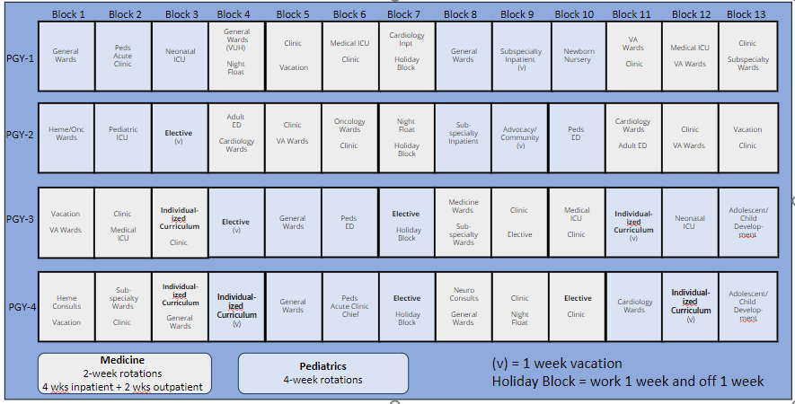
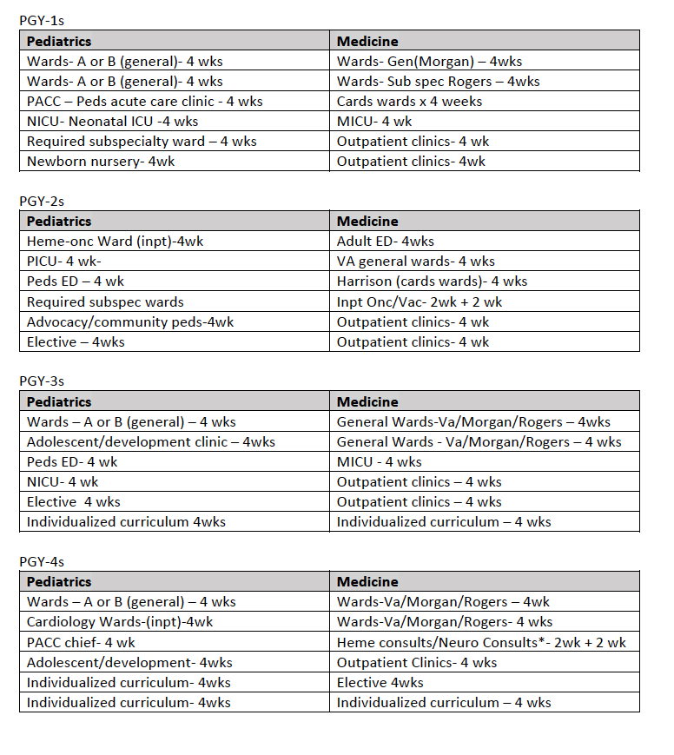

ACGME Internal Medicine sub-competencies
(milestones)

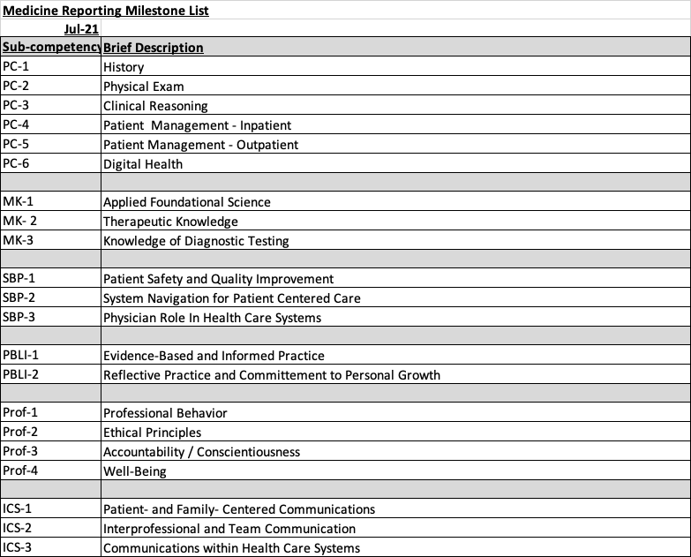
ACGME Pediatric sub-competencies
(milestones)

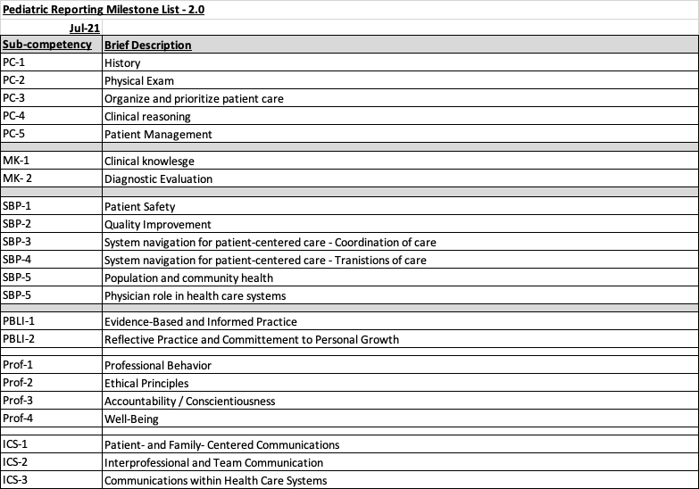

Vanderbilt Combined Med-Peds
Curriculum Specific to Med-Peds (PGY-1s)

1) Med-Peds Conference Series

a) Clinical Masters Conference
Goal: Expose first year residents to the clinical problem-solving practices of clinical masters. Clinical masters are invited speakers among the best in the institution. Interns will be able to watch how clinical masters solve clinical problems and learn improved clinical problem solving by example.
Expectations: Attendance is required. Interns will be excused if they are in an ICU, post-call/nights, caring for an emergent patient need or on vacation.
Learning objectives
As a result of participating in the Clinical Masters Conference, interns should be able to:
• Describe and discuss clinical problem-solving strategies demonstrated by clinical masters. (MK, PC)
• Critically assess clinical problem-solving strategies demonstrated by clinical masters. (MK, PC)
• Incorporate demonstrated strategies into personal approaches to clinical problem solving (PC, P)
Supervision and assessment:
• Attendance will be taken at each conference by the program coordinator.
• Clinical problem-solving will be assessed by attending physicians.

b) Critically Appraised Topics (CAT) Conference
Goal: Introduce the concept of CATs by observing how more senior residents access, evaluate and use the medical literature to succinctly answer focused, specific clinical questions.
Expectations: Attendance is required. Interns will be excused if they are in an ICU, post-call/nights, caring for an emergent patient need or on vacation. Feedback forms for each resident speaker are provided for all faculty and residents in attendance.
Learning objectives:
As a result of participating in the Critically Appraised Topics Conference, interns should be able to:
• Describe and discuss the purpose of a CAT (ICS, MK, PBLI)
• Explain the intent and rationale for brevity of a CAT (ICS, MK, PBLI)
• Access and evaluate the medical literature as the first step in developing a CAT that will answer a clinical question. (ICS, MK, PBLI)
Supervision and assessment:
• Attendance will be taken at each conference by the program coordinator.
• Critically appraised topics (CATs) will be assessed by attending physicians.

c) Scholarship and Teaching as Residents (STAR) Conference
Goal: Introduce interns to concepts required for effective teaching and poster design. This includes how to create goals and objectives, how to create and present educational materials, and how to teach effectively in a small group setting.
Expectations: Attendance is required. Interns will be excused if they are in an ICU, post-call/nights, caring for an emergent patient need or on vacation. Feedback forms for each speaker are provided for all faculty and residents in attendance.
Learning Objectives
As a result of participating in the STAR Conference, interns should be able to:
• Create learning goals and objectives for medical teaching and educational materials. (ICS, P)
• Create posters based on accepted educational principles (ICS, P)
• Teach effectively in small groups. (ICS, P)
Supervision and assessment
• Attendance will be taken at each conference by the program coordinator.
• Teaching skills will be assessed by attending physicians.

d) Quality Improvement (QI) and Patient Safety Conference
Goal: Introduce interns to the tools used for process improvement and patient safety in a clinical health care setting.
Expectations: Interns will have the opportunity to create quality improvement projects within their own resident practice, within the Med-Peds practice cohort or with a sentinel event within the hospital or clinic setting of their choice. Attendance is required. Interns will be excused if they are in an ICU, post-call/nights, caring for an emergent patient need or on vacation.
Learning Objectives:
At the end of the first year of the QI conference series, interns should be able to:
• Describe and discuss how to implement a PDSA cycle (PBLI, SBP)
• Use EMR-based tools to query their own panels for quality metrics (PBLI, SBP)
• Use a fishbone diagram to evaluate a patient safety event (PBLI, SBP)
Supervision and assessment:
• Attendance will be taken at each conference by the program coordinator.
• The APD for QI, clinic attendings, and PD will oversee demonstration of QI and Patient Safety skills.

e) Clinical Skills (CS) Conference
Goal: Introduce interns to clinical skills they will need in the inpatient and outpatient setting, and give them a chance to practice these skills and ask questions to an expert

Expectations: Interns will attend and participate in each of the clinical skills sessions. Interns will be excused if they are in an ICU, post-call/nights, caring for an emergent patient need or on vacation. They will actively ask questions on those topics that are unclear.
Learning Objectives:
At the end of the first year of the clinical skills series, interns should be able to:
• Demonstrate improved skills in global physical exam skills
• Demonstrate improved accuracy in reading EKGs, CXR, and other tools for direct patient care (PC, MK, PBLI)
Supervision and assessment:
• Attendance will be taken at each conference by the program coordinator.
• Their clinic preceptor will review the clinical skills acquisition with them in real time in the outpatient clinic setting. The PD will also review all attending feedback on these skills. (PC, MK, PBLI)

2) Med-Peds Combined Continuity Clinic
Goal: Expose interns in the continuity clinic to a wide array of patients of all ages presenting for health maintenance, acute care problem-based visits, and chronic disease management (such as diabetes, hypertension and high cholesterol), and to provide an opportunity for interns to begin to develop a sound approach for managing these patients during these visits.
Expectations: Interns will be expected to see a minimum of 54 adult and 54 pediatric patients over a one-year period. They will have a minimum of 36 clinic weeks each year. The Med-Peds case-based outpatient curriculum is used to facilitate ambulatory clinical learning in clinic.
Learning objectives:
At the end of the intern year, the PGY-1 resident should be able to:
• Conduct complete health maintenance visits for persons of all ages (PC, MK, ICS, P)
• Describe and discuss all resources for routine screening, health maintenance and vaccines for all ages (PC, MK, ICS, P)
• Create initial plans for patients with routine acute presenting problems and routine chronic disease management (PC, MK, ICS, P)
• Know their limits in diagnosing complex cases and knowing when to ask for help. (PC, MK, ICS, P)
• Summarize and use when appropriate information presented in the case-based pre-clinic curriculum. (PC, MK, ICS, P)
Supervision and assessment:
• A faculty member who is board certified in both Internal Medicine and Pediatrics will precept each clinic. This preceptor will see all patients with the intern for the first 6 months of the year. After that initial time period, depending on the comfort level of both the intern and the attending, they are permitted to check patients out to the attending verbally without direct patient interaction by the attending seeing each patient.

• Direct verbal feedback is given by the attending is given in real time with every patient. Written feedback is provided periodically after direct observation on specific skills, periodically in summary of ongoing observations, and anytime requested.

3) Med-Peds Scholarly Project
Goal: Provide interns exposure to the community of scholars in Med-Peds at regional or national medical society meeting and an opportunity to participate in this community by making scholarly presentations.
Expectations: Interns may create scholarly materials that will be shared with learners at a local, regional or national level. The exact requirements are intentionally left vague to encourage
creativity and to allow for very different learners with very different ultimate career goals. Examples could include, but are not limited to: posters of case presentations presented at regional, or national meetings; original basic research; original health services research; creation of clinical teaching materials reaching an audience beyond Vanderbilt; service projects and teaching projects that
impact a significant number of learners locally or regionally, etc. This project may be completed at any level within the 4 years of residency.
Learning Objectives:
At the completion of the scholarly project, the learner should be able to:
• Make an effective formal presentation at a regional or national level. (ICS, P, MK)
• Create learning materials in a generally accepted scholarly format that can be shared with the med peds community (ICS, P, MK)
Supervision and assessment:
• The entire Med-Peds faculty will serve as resource for these projects. Residents may also find faculty support outside the combined Med-Peds faculty.
• The Program Director and/or Associate Program Director will confirm with each resident that their proposed project meets the above intentions that their final project is acceptable.

Vanderbilt Combined Med-Peds
Goals and Objectives (PGY-2-3s)

1) Med-Peds Conference Series

a) Clinical Masters Conference
Goal: Expose second- and third-year residents to the clinical problem-solving practices of clinical masters. Clinical masters are invited speakers among the best in the institution. Residents will be able to watch how clinical masters and senior residents solve clinical problems and learn improved clinical problem solving by example.
Expectations: Attendance is required. Residents will be excused if they are in an ICU, post-call/nights, caring for an emergent patient need or on vacation.
Learning objectives
As a result of participating in the Clinical Masters Conference, residents should be able to:
• Describe and discuss clinical problem-solving strategies demonstrated by clinical masters. (MK, PC)
• Critically assess clinical problem-solving strategies demonstrated by clinical masters. (MK, PC)
• Incorporate demonstrated strategies into personal approaches to clinical problem solving (PC, P)
Supervision and assessment:
• Attendance will be taken at each conference by the program coordinator.
• Clinical problem-solving will be assessed by attending physicians.

b) Critically Appraised Topics (CAT) Conference
Goal: Provide second- and third-year residents residents to develop CATs with senior resident and faculty guidance by accessing, evaluating and using the medical literature to succinctly answer focused, specific clinical questions.
Expectations: Attendance is required. Residents will be excused if they are in an ICU, post-call/nights, caring for an emergent patient need or on vacation. Feedback forms for each speaker are provided for all faculty and residents in attendance.
Learning objectives:
As a result of participating in the CAT Conference, residents should be able to:
• Use the CAT maker tool. (ICS, MK, PBLI)
• Explain the purpose, intent and rationale for brevity of a CAT (ICS, MK, PBLI)
• Create personal CATs by accessing, evaluating and using the medical literature to succinctly answer focused, specific clinical questions. (ICS, MK, PBLI)
• Present a CAT that they have developed to other residents with faculty support.
Supervision and assessment:
• Attendance will be taken at each conference by the program coordinator.
• Critically appraised topics (CATs) will be assessed by attending physicians.

c) Scholarship and Teaching as Residents (STAR) Conference
Goal: Provide second- and third-year residents with opportunities to continue to learn to be better teachers. This will be accomplished by creating goals and objectives for each session that they teach and by beginning to evaluate what they are teaching. Residents may present posters or other scholarly projects that they plan to present in professional settings or develop original relevant educational content.
Expectations: Attendance is required. Residents will be excused if they are in an ICU, post-call/nights, caring for an emergent patient need or on vacation. Feedback forms for each speaker are provided for all faculty and residents in attendance.
Learning Objectives
As a result of participating in the STAR Conference, residents should be able to:
• Create learning goals and objectives for medical teaching and educational materials. (ICS, P)
• Create posters based on accepted educational principles (ICS, P)
• Teach effectively in small and large groups. (ICS, P)
Supervision and assessment
• Attendance will be taken at each conference by the program coordinator.
• Teaching skills and methods will be assessed by attending physicians.

d) Quality Improvement (QI) and Patient Safety Conference
Goal: Provide second- and third-year residents with an opportunity to further develop skills to use tools for process improvement and patient safety in a clinical health care setting.
Expectations: Residents will have the opportunity to create quality improvement projects within their own resident practice, within the Med-Peds practice cohort or with a sentinel event within the hospital or clinic setting of their choice. Attendance is required. Residents will be excused if they are in an ICU, post-call/nights, caring for an emergent patient need or on vacation. Feedback forms for each speaker are provided for all faculty and residents in attendance.
Learning Objectives:
After participating in the QI conference, residents should be able to:
• Describe and discuss how to implement a PDSA cycle (PBLI, SBP)
• Use EMR-based tools to query their own panels for quality metrics (PBLI, SBP)
• Use a fishbone diagram to evaluate a patient safety event (PBLI, SBP)

Supervision and assessment:
• Attendance will be taken at each conference by the program coordinator.
• The APD for QI, clinic attendings, and PD will oversee demonstration of QI and Patient Safety skills.

e) Clinical Skills (CS) Conference
Goal: To create excellence in basic clinical skills resident will need in the inpatient and
outpatient setting, and give them a chance to practice these skills and ask questions to an expert

Expectations: PGY-2s and 3 residents will attend and participate with each of the clinical skills sessions. Residents will be excused if they are in an ICU, post-call/nights, caring for an emergent patient need or on vacation. They will actively ask questions on those topics that are unclear.
Learning Objectives:
At the end of the first year of the clinical skills series, interns should be able to:
• Demonstrate improved skills in global physical exam skills
• Demonstrate improved accuracy in reading EKGs, CXR, and other tools for direct patient care (PC, MK, PBLI)
Supervision and assessment:
• Attendance will be taken at each conference by the program coordinator.
• Their clinic preceptor will review the clinical skills acquisition with them in real time in the outpatient clinic setting. The PD will also review all attending feedback on these skills. (PC, MK, PBLI)

2) Med-Peds Combined Continuity Clinic
Goal: Expose second- and third-year residents in the continuity clinic to a wide array of patients of all ages presenting for health maintenance, acute care problem-based visits, and chronic disease management (such as diabetes, hypertension and high cholesterol), and provide an opportunity for them to refine their approaches for managing these patients during these visits. As a resident grows in clinical skills and professional maturity, the attending and senior resident will allow the resident
to practice with increasing independence.
Expectations: Residents at PGY- 2 will be expected to see a minimum of 72 adult and 72 pediatric patients over a one-year period. Residents at the PGY3- level will be expected to see a minimum of
90 adults and 90 children over a one-year period. They will have a minimum of 36 clinic weeks each year. The Med-Peds case-based outpatient curriculum is used to facilitate ambulatory clinical learning in clinic.
Learning objectives:
At the end of the PGY 2 and 3 year, the PGY 2 and 3 resident should be able to:
• Conduct a comprehensive health maintenance visit for persons of all ages (PC, MK, ICS, P)
• Access as indicated resources for routine screening, health maintenance and vaccines for all ages (PC, MK, ICS, P)
• Provide anticipatory guidance and health maintenance counseling as indicated. (PC, MK, ICS, P)
• Create substantial plans for patients with routine acute presenting problems and routine chronic disease management which will be subject to review and amendment by the attending physician. (PC, MK, ICS, P)
• Know their limits in diagnosing complex cases and knowing when to ask for help. (PC, MK, ICS, P)
• Summarize and use when appropriate information presented in the case-based pre-clinic curriculum. (PC, MK, ICS, P)

Supervision and assessment:
• A faculty member who is board certified in both Internal Medicine and Pediatrics will precept each clinic. The preceptor is available at all times during clinic for question or consultation, and will see any patient that a resident has questions about or feel unsure about their assessment or plan. As the resident progresses through the PGY-2 and PGY-3 year, they will need attending consultation less and less and begin to function increasingly independently.
• Direct verbal feedback is given by the attending is given in real time with every patient. Written feedback is provided periodically after direct observation on specific skills, periodically in summary of ongoing observations, and anytime requested.

3) Med-Peds Scholarly Project
Goal: Provide PGY- 2 and 3 residents exposure to the community of scholars in Med-Peds at regional or national medical society meeting and an opportunity to participate in this community by making scholarly presentations.
Expectations: Residents will continue to work with a mentor in their area of academic interest. They will work with this mentor, or one of the med-peds faculty whom they choose, who will help them identify and create their scholarly project. Residents will create scholarly materials that will be shared with learners at a local, regional or national level. The exact requirements are intentionally left vague to encourage creativity and to allow for very different learners with very different ultimate career goals. Examples could include, but are not limited to: posters of case presentations
presented at regional, or national meetings; original basic research; original health services research; creation of clinical teaching materials reaching an audience beyond Vanderbilt; service projects and teaching projects that impact a significant number of learners locally or regionally, etc. This project may be completed at any level within the 4 years of residency.
Learning Objectives:
At the completion of the scholarly project, the learner should be able to:
• Make a formal presentation at a regional or national level (ICS, P, MK)
• Create learning materials in a generally acceptable scholarly format that can be shared with the med peds community (ICS, P, MK)
Supervision and assessment:
• The entire Med-Peds faculty will serve as resource for these projects. Residents may also find faculty support outside the combined Med-Peds faculty.
• The Program Director and/or Associate Program Director will confirm with each resident that their proposed project meets the above intentions that their final project is acceptable.

Vanderbilt Combined Med-Peds
Goals and Objectives (PGY-4s)

1) Med-Peds Conference Series

a) Clinical Masters Conference
Goal: Provide PGY-4 residents with an opportunity to serve as a role model for junior residents and residents based on the clinical problem-solving practices of clinical masters. Clinical masters are invited speakers among the best in the institution. Senior residents should be able to participate in clinical problem solving cases taught by clinical masters and learn improved clinical problem solving by example.
Expectations: Attendance is required. Residents will be excused if they are in an ICU, post-call/nights, caring for an emergent patient need or on vacation.
Learning objectives
As a result of participating in the Clinical Masters Conference, resident should be able to:
• Describe and discuss clinical problem-solving strategies demonstrated by clinical masters. (MK, PC)
• Critically assess clinical problem-solving strategies demonstrated by clinical masters. (MK, PC)
• Incorporate demonstrated strategies into personal approaches to clinical problem solving (PC, P)
• Serve as role model for junior residents and residents. (MK, PC, P)
Supervision and assessment:
• Attendance will be taken at each conference by the program coordinator.
• Clinical problem-solving will be assessed by attending physicians.

b) Critically Appraised Topics (CAT) Conference
Goal: Provide an opportunity for senior residents to develop a CAT presentation independently, continuing to use the CAT maker tool and using the literature to answer focused, specific clinical questions, and then presenting the results to their resident colleagues. After a year of participation by observation, and two years participating in creating these conferences with faculty and senior resident guidance, senior residents should serve as a role model for the more junior residents.
Expectations: Attendance is required. Residents will be excused if they are in an ICU, post-call, caring for an emergent patient interaction or on vacation. Feedback forms for each speaker are provided for all faculty and residents in attendance.
Learning objectives:
As a result of participating in the CAT Conference, residents should be able to:
• Use the CAT maker tool effectively. (ICS, MK, PBLI)
• Explain the purpose, intent and rationale for brevity of a CAT. (ICS, MK, PBLI)
• Deliver an effective, concise informative CAT conference with minimal faculty support. (ICS, MK, PBLI)
• Serve as a role model for more junior learners.

Supervision and assessment:
• Attendance will be taken at each conference by the program coordinator.
• Critically appraised topics (CATs) will be assessed by attending physicians.

c) Scholarship and Teaching as Residents (STAR) Conference
Goal: Provide an opportunity for senior resident to demonstrate their successful development as teachers. This will be accomplished by referring to the goals and objectives for each session that they teach and by showing how they evaluate what they are teaching. Residents will be provided an opportunity to present posters or other scholarly projects that they plan to present in professional settings. Senior residents and attendings will critique the presentations.
Expectations: Attendance is required. Residents will be excused if they are in an ICU, post-call, caring for an emergent patient interaction or on vacation. Feedback forms for each speaker are provided for all faculty and residents in attendance.
Learning Objectives
As a result of participating in the STAR Conference, residents should be able to:
• Create learning goals and objectives for medical teaching and educational materials. (ICS, P)
• Create posters based on accepted educational principles (ICS, P)
• Teach effectively in small and large groups. (ICS, P)
• Model successful approaches to teaching and assessment to more junior residents.
Supervision and assessment
• Attendance will be taken at each conference by the program coordinator.
• Teaching and posters will be assessed by attending physicians.

d) Quality Improvement (QI) and Patient Safety Conference
Goal: Provide PGY 4 residents with an opportunity to further refine their skills using tools for process improvement and patient safety in a clinical health care setting.
Expectations: Residents will have the opportunity to create quality improvement projects within their own resident practice, within the med-peds practice cohort or with a sentinel event within the hospital or clinic setting of their choice. Attendance is required. Residents will be
excused if they are in an ICU, post-call, caring for an emergent patient interaction or on vacation. Feedback forms for each speaker are required of all faculty and residents in attendance.
Learning Objectives:
At the end of the first year of the QI conference series, residents should be able to:
• Describe and discuss how to implement a PDSA cycle (PBLI, SBP)
• Use EMR-based tools to query their own panels for quality metrics (PBLI, SBP)
• Use a fishbone diagram to evaluate a patient safety event (PBLI, SBP)
Supervision and assessment:
• Attendance will be taken at each conference by the program coordinator.
• The APD for QI, clinic attendings, and PD will oversee demonstration of QI and Patient Safety skills.

e) Clinical Skills (CS) Conference
Goal: To create excellence in basic clinical skills resident will need in the inpatient and
outpatient setting, and give residents a chance to practice these skills and ask questions to an expert.

Expectations: Residents will participate in all clinical skills conferences. Residents will be excused if they are in an ICU, post-call/nights, caring for an emergent patient need or on vacation. At the end of this year, senior resident will be prepared and competent to perform these skills independently, correctly and appropriately.

Learning Objectives:
Senior residents should be able to:
• Demonstrate proficiency with the skills in global physical exam skills
• Demonstrate competence for independent practice in in reading EKGs, CXR, and other tools for direct patient care (PC, MK, PBLI)
Supervision and assessment:
• Attendance will be taken at each conference by the program coordinator.
• Their clinic preceptor will review the clinical skills acquisition with them in real time in the outpatient clinic setting. The PD will also review all attending feedback on these skills. (PC, MK, PBLI)

2) Med-Peds Combined Continuity Clinic
Goal: Expose PGY-4 residents in the continuity clinic to a wide array of patients of all ages presenting for health maintenance, acute care problem-based visits, and chronic disease management such as diabetes, hypertension and high cholesterol, and to begin to develop a sound approach for
managing these patients during these visits. A PGY-4 resident should be practicing with
considerable independence and minimal oversight by attending physicians. A PGY-4 resident will be supervising the practice of more junior residents.
Expectations: PGY-4 residents are expected to see a minimum of 90 adult and 90 pediatric patients over a one-year period. They will have a minimum of 36 clinic weeks each year. The Med-Peds case-based outpatient curriculum is used to facilitate ambulatory clinical learning in clinic.
Learning objectives:
At the end of the intern year, the PGY-4 resident should be able to:
• Conduct a comprehensive health maintenance visit for persons of all ages (PC, MK, ICS, P)
• Access all indicated resources for routine screening, health maintenance and vaccines for all ages (PC, MK, ICS, P)
• Provide anticipatory guidance and health maintenance counseling to patients as indicated. (PC, MK, ICS, P)
• Create substantial plans for patients with routine acute presenting problems and routine chronic disease management. (PC, MK, ICS, P)
• Know their limits in diagnosing complex cases and knowing when to ask for help. (PC, MK, ICS, P)

• Summarize and use when appropriate information presented in the case-based pre-clinic curriculum. (PC, MK, ICS, P)
• Supervise junior residents and interns.
Supervision and assessment:
• A faculty member who is board certified in both Internal Medicine and Pediatrics will precept each clinic. The preceptor is available at all times during clinic for question or consultation, and will see any patient that a resident has questions about or feel unsure about their assessment or plan. As the resident progresses through the PGY-4 year, he or she will be functioning independently.
• Direct verbal feedback is given by the attending is given in real time with every patient. Written feedback is provided periodically after direct observation on specific skills, periodically in summary of ongoing observations, and anytime requested.

3) Med-Peds Scholarly Project
Goal: Provide residents with exposure to the community of scholars in Med-Peds at regional or national medical society meeting and an opportunity to participate in this community by making scholarly presentations.
Expectations: Residents will continue to work with a mentor in their area of academic interest. They will work with this mentor, or one of the med-peds faculty whom they choose, who will provide guidance on their scholarly project. Residents will create scholarly materials that will be shared with learners at a local, regional or national level. The exact requirements are intentionally left vague to encourage creativity and to allow for very different learners with very different ultimate career goals. Examples could include, but are not limited to: posters of case presentations presented at regional,
or national meetings; original basic research; original health services research; creation of clinical teaching materials reaching an audience beyond Vanderbilt; service projects and teaching projects that impact a significant number of learners locally or regionally, etc. This project may be completed at any level within the 4 years of residency.
Learning Objectives:
At the completion of the scholarly project, the learner should be able to:
• Make a formal presentation at a regional or national level (ICS, P, MK)
• Create learning materials in a typical format that can be shared with the med peds community (ICS, P, MK)
Supervision and assessment:
• The entire Med-Peds faculty will serve as resource for these projects. Residents may also find faculty support outside the combined Med-Peds faculty.
• The Program Director and/or Associate Program Director will confirm with each resident that their proposed project meets the above intentions that their final project is acceptable.

